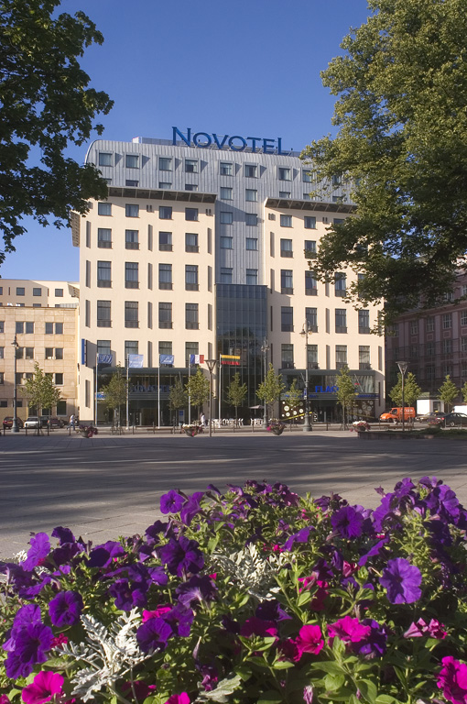

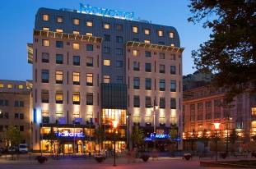




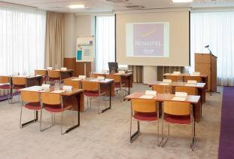
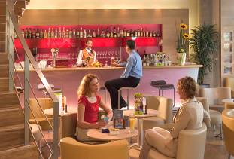



REGISTRATION FORM
12 th International Conference
10-14/07/2011

VILNIUS Tel. +370 5 2666 200
Gedimino av. 16Fax +370 5 2666 201
LT 01103 VILNIUS E-mail h5209@accor.com
Please return this form by fax or by e-mail by 01/06/2011
NameAddressEmailTelephoneArrival DateDeparture DateStandart Room for 1 person/85EURStandart Room for 2 persons/95EURSpecial accommodation RequestsType of CardCard NumberExpire Date*Rate includes full buffet breakfast , entrance to fitness center (sauna, steam bath, gym),VAT and service taxes
* Free WiFi internet is available for hotel guests all over hotel premises.

VILNIUS
Gedimino av. 16
LT 01103 VILNIUS
LITHUANIA

Tel. +370 5 2666 200
Fax +370 5 2666 201
E-mail h5209@accor.com
www.novotel.com

